Asset Inventory Tool  
Use the below tool to inventory your region’s assets. Consider all the region’s assets that are in good condition. Be especially mindful of any underutilized assets that may be made useful.

|  |  |  |  |
| --- | --- | --- | --- |
|  | **The Capitals** | **Definitions** | **What do we have?** |
|  | **Individual** | Skills, understanding, physical health and mental wellness in a region’s people |  |
|  | **Intellectual** | Knowledge, resourcefulness, creativity and innovation in a region’s people, institutions, organizations and sectors. |  |
|  | **Social** | Trust, relationships and networks in a region’s population. |  |
|  | **Cultural** | Traditions, customs, ways of doing, and world views in a region’s population. |  |
|  | **Natural** | Natural resources—for example, water, land, air, plants and animals—in a region’s places. |  |
|  | **Built** | Constructed infrastructure—for example, buildings, sewer systems, broadband, roads—in a region’s places. |  |
|  | **Political** | Goodwill, influence and power that people, organizations and institutions in the region can exercise in decision-making. |  |
|  | **Financial** | Monetary resources available in the region for investment in the region. |  |

# Spider Diagram Tool - Defining Wealth: What is the Relative Strength of the Capitals in my Region?

### **Introduction** One resource that is often used at the community or regional level is the spider diagram, which allows those in a community to rate how the community is doing across different forms of capital. Questions to ask as you engage with the spider diagram include:

1. What kinds of wealth and how much of each does the region have? It is only wealth if it is healthy and fully functional and if the region owns or controls it and can make decisions about how to maintain and use it.
2. Map out the strengths of each of the capitals for your region (0 is weakest and 5 is strongest).

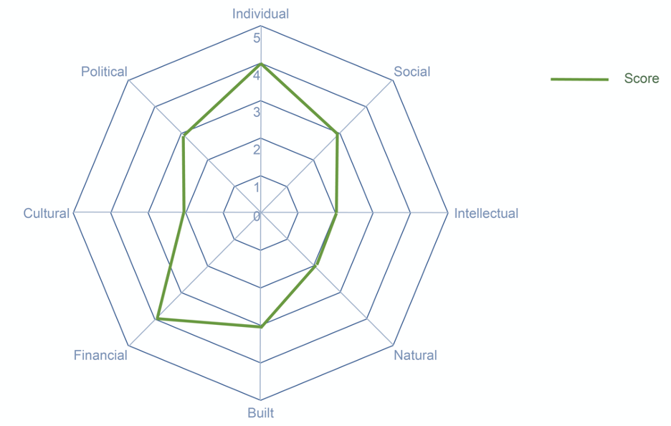

This exercise provides a way to communicate about the community’s assets. When done in a group of community members, it often surfaces discussion about perceptions and realities when it comes to community strengths and weaknesses.

### **Instructions**

Think about your region. What kinds of wealth and how much of each does that region have? Remember, it is only wealth if it is healthy and fully functional and if the region owns or controls it and can make decisions about how to maintain it and use it.

Using the spider diagram and the scale of 0 to 5 (where 0 is the weakest and 5 is the strongest), map out the strengths of each of the capitals for your region.

