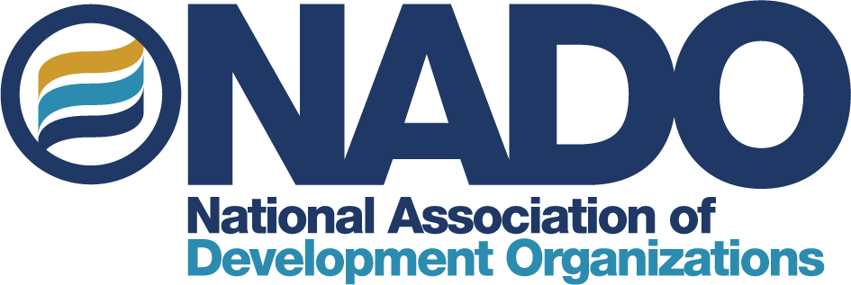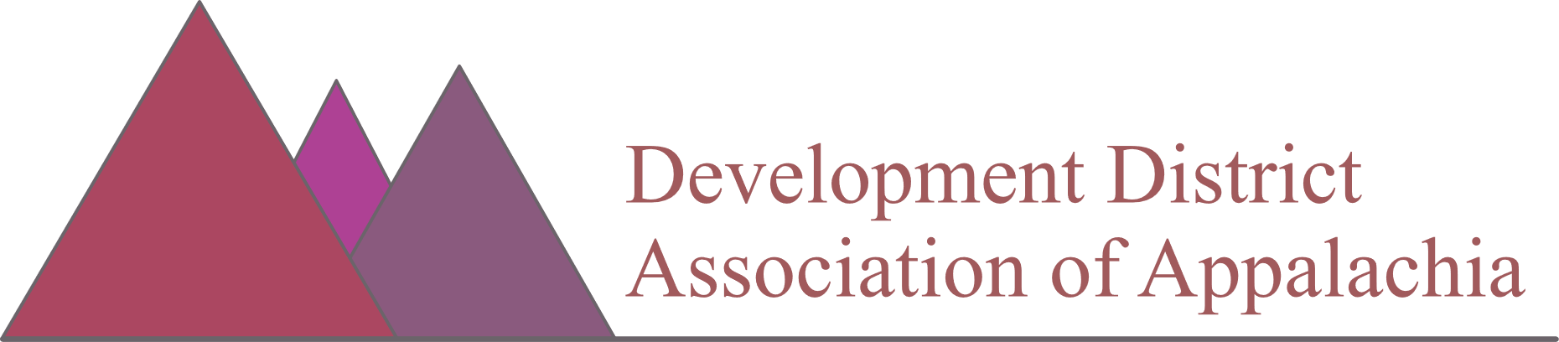

Increase FY24 ARC Local Development District Administrative Funding
Although annual funding for the Appalachian Regional Commission (ARC) has increased significantly over the last five years, critical support funding for Local Development Districts (LDDs) has not kept pace, placing a heavy administrative burden on the same communities that ARC is designed to support. The Bipartisan Infrastructure Law also provided a record $1 billion for ARC but did not provide any designated LDD administrative support funding.
(Budget figures are in millions) | FY 2019 | FY 2020 | FY 2021 | FY 2022 | FY 2023 | FY 2024  NADO request
ARC Total Appropriation | $165 | $175 | $180 | $195 | $200
ARC LDD Admin Funding | $6.2 | $6.2 | $6.2 | $8 | $8 | $18 million
Action needed: Congress should increase FY24 Energy and Water appropriations funding for ARC Local Development Districts to $18 million.

How Much Funding is Provided to Local Development Districts?
Until recently, the appropriated funding level for Local Development Districts (LDDs) had remained stagnant at $6.2 million for many years. In FY22, Congress took an important step by increasing this level to $8 million for both FY22 and FY23. The LDDs are very grateful for this increase. Nevertheless, the ARC’s overall appropriation has continued to receive substantial increases, while support for LDDs has remained relatively flat. This was only further exacerbated by the landmark $1 billion for ARC included in the Bipartisan Infrastructure Law, which did not include any direct support funding for LDDs.

Divided among the 74 LDDs within the ARC region, the current level of $8 million correlates to approximately $108,000 per LDD. In most communities, this funding level of $108,000 is rarely enough to fund more than one full-time staff member. Most LDDs cover numerous counties, cities, and towns, so one staff person covering such a large region is already stretched very thin. Furthermore, in order for each LDD organization to receive their funding distribution, the LDD must provide matching funds.

Congressional Action Needed
In FY24, NADO and DDAA encourage Congress to appropriate $18 million for ARC Local Development District administrative funding to allow LDDs to add additional staff capacity to assist in the administration and implementation of increasingly larger and more complex ARC investments.

Why are Local Development Districts Important?
Both ARC, at the federal level -- and local communities, at the regional level -- rely upon LDDs, because:
- LDDs help other local stakeholders apply for ARC grants
- LDDs administer ARC project funding and assist with project implementation
- LDDs help local ARC grantees steward the funding they receive properly
- LDDs lead and leverage local partnerships and help identify local projects that are eligible for ARC funding

Overview: The Appalachian Regional Commission (ARC)
Established by an act of Congress in 1965, the Appalachian Regional Commission (ARC) is an economic development partnership agency of the federal government and 13 states. The ARC is led by the Governors of the Appalachian states and by a Presidentially-appointed Federal Co-Chair. Every year, Congress appropriates funding for ARC and its programs, administered among its 13 member states: Alabama, Georgia, Kentucky, Maryland, Mississippi, New York, North Carolina, Ohio, Pennsylvania, South Carolina, Tennessee, and Virginia, and West Virginia. ARC serves 423 counties and facilitates economic and community development, with an emphasis on mitigating economic distress. ARC invests in a variety of priorities including workforce development, critical infrastructure projects including water infrastructure, sewer systems and broadband, safe and efficient highway systems, and entrepreneurial support and capital market development.

Overview: Local Development Districts (LDDs)
Local Development Districts (LDDs) are multi-jurisdictional, locally based community organizations that facilitate economic development and support ARC-funded initiatives. LDDs are often known locally by a variety of different names such as “Councils of Government” (COGs), “Planning and Development Districts” (PDDs), “Area Development Districts” (ADDs), or “Regional Planning Councils” (RPCs), but are collectively referred to as LDDs. Within the ARC service area, 74 LDDs support and foster intergovernmental collaboration, provide grant writing support and technical assistance to other local organizations in their regions, facilitate project implementation, and play important roles in administering federal, state, and local programs. Guided by local leaders, elected officials, small business and private sector representatives, and other community stakeholders, ARC relies on LDDs to lead local partnerships, to administer ARC project funding, and to help other local organizations applying for ARC grant funding.

About NADO
The National Association of Development Organizations (NADO) advocates for the national network of Regional Development Organizations (RDOs) across the country, including the Local Development Districts within the ARC Region.

About DDAA
The Development District Association of Appalachia (DDAA) is a membership organization of the 74 Local Development Districts (LDDs) serving the Appalachia Region. DDAA works to align and strengthen LDDs as they provide support to the Appalachian Regional Commission.

Contact
For more information, please contact Mirielle Burgoyne, NADO’s Director of Government Relations, at mburgoyne@nado.org

The amount that each individual LDD receives varies.

