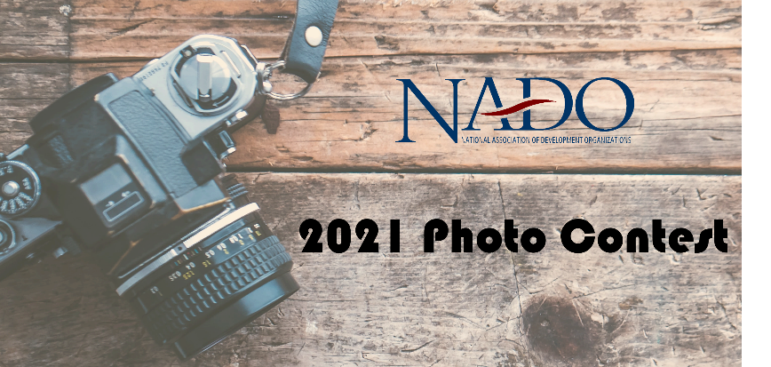
2021 NADO Photo Contest Entry Form
Thank you for participating in the 2021 NADO Photo Contest! Please submit this completed form, along with your photos, via e-mail to Brett Schwartz at bschwartz@nado.org by September 10, 2021. If your files are too large to e-mail, you may also submit via Dropbox to the same e-mail address after providing notification.
/////////////////////////////////////////////////////
Please check:
[ ] I have read the rules and submission requirements for the NADO Photo Contest at NADO.org
[ ] My organization is a NADO member
[ ] I understand that the photos submitted may be used in NADO and NADO Research Foundation publications and presentations, as well as on NADO’s website/social media channels
Name:
Organization:
E-mail:
Date:
Please check the categories for which you are submitting photos (2 photos maximum per category):
[ ] Building Vibrant Places
[ ] Strengthening the Built and Natural Environments
[ ] Investing in Our Regional Economy
[ ] Sustaining Our Communities
[ ] COVID-19 Response and Recovery
Complete the following information for each photo submitted (cut and paste more sections if necessary):
The subject of the photo is:
The location of the photo is:
The staff member who took the photo is:
Please direct any questions to NADO Research Foundation Associate Director Brett Schwartz at bschwartz@nado.org

