Spider Diagram Exercise: What is the Relative Strength of the Capitals in my Region?

Introduction
Think about your region. What kinds of wealth and how much of each does that region have? Remember, it is only wealth if it is healthy and fully functional and if the region owns or controls it and can make decisions about how to maintain it and use it.

Instructions
- Using the spider diagram and the scale of 0 to 5 (where 0 is the weakest and 5 is the strongest), map out the strengths of each of the capitals for your region.
- Then share with someone else.
- Explain what you came up with and why.
- Debrief.

Example
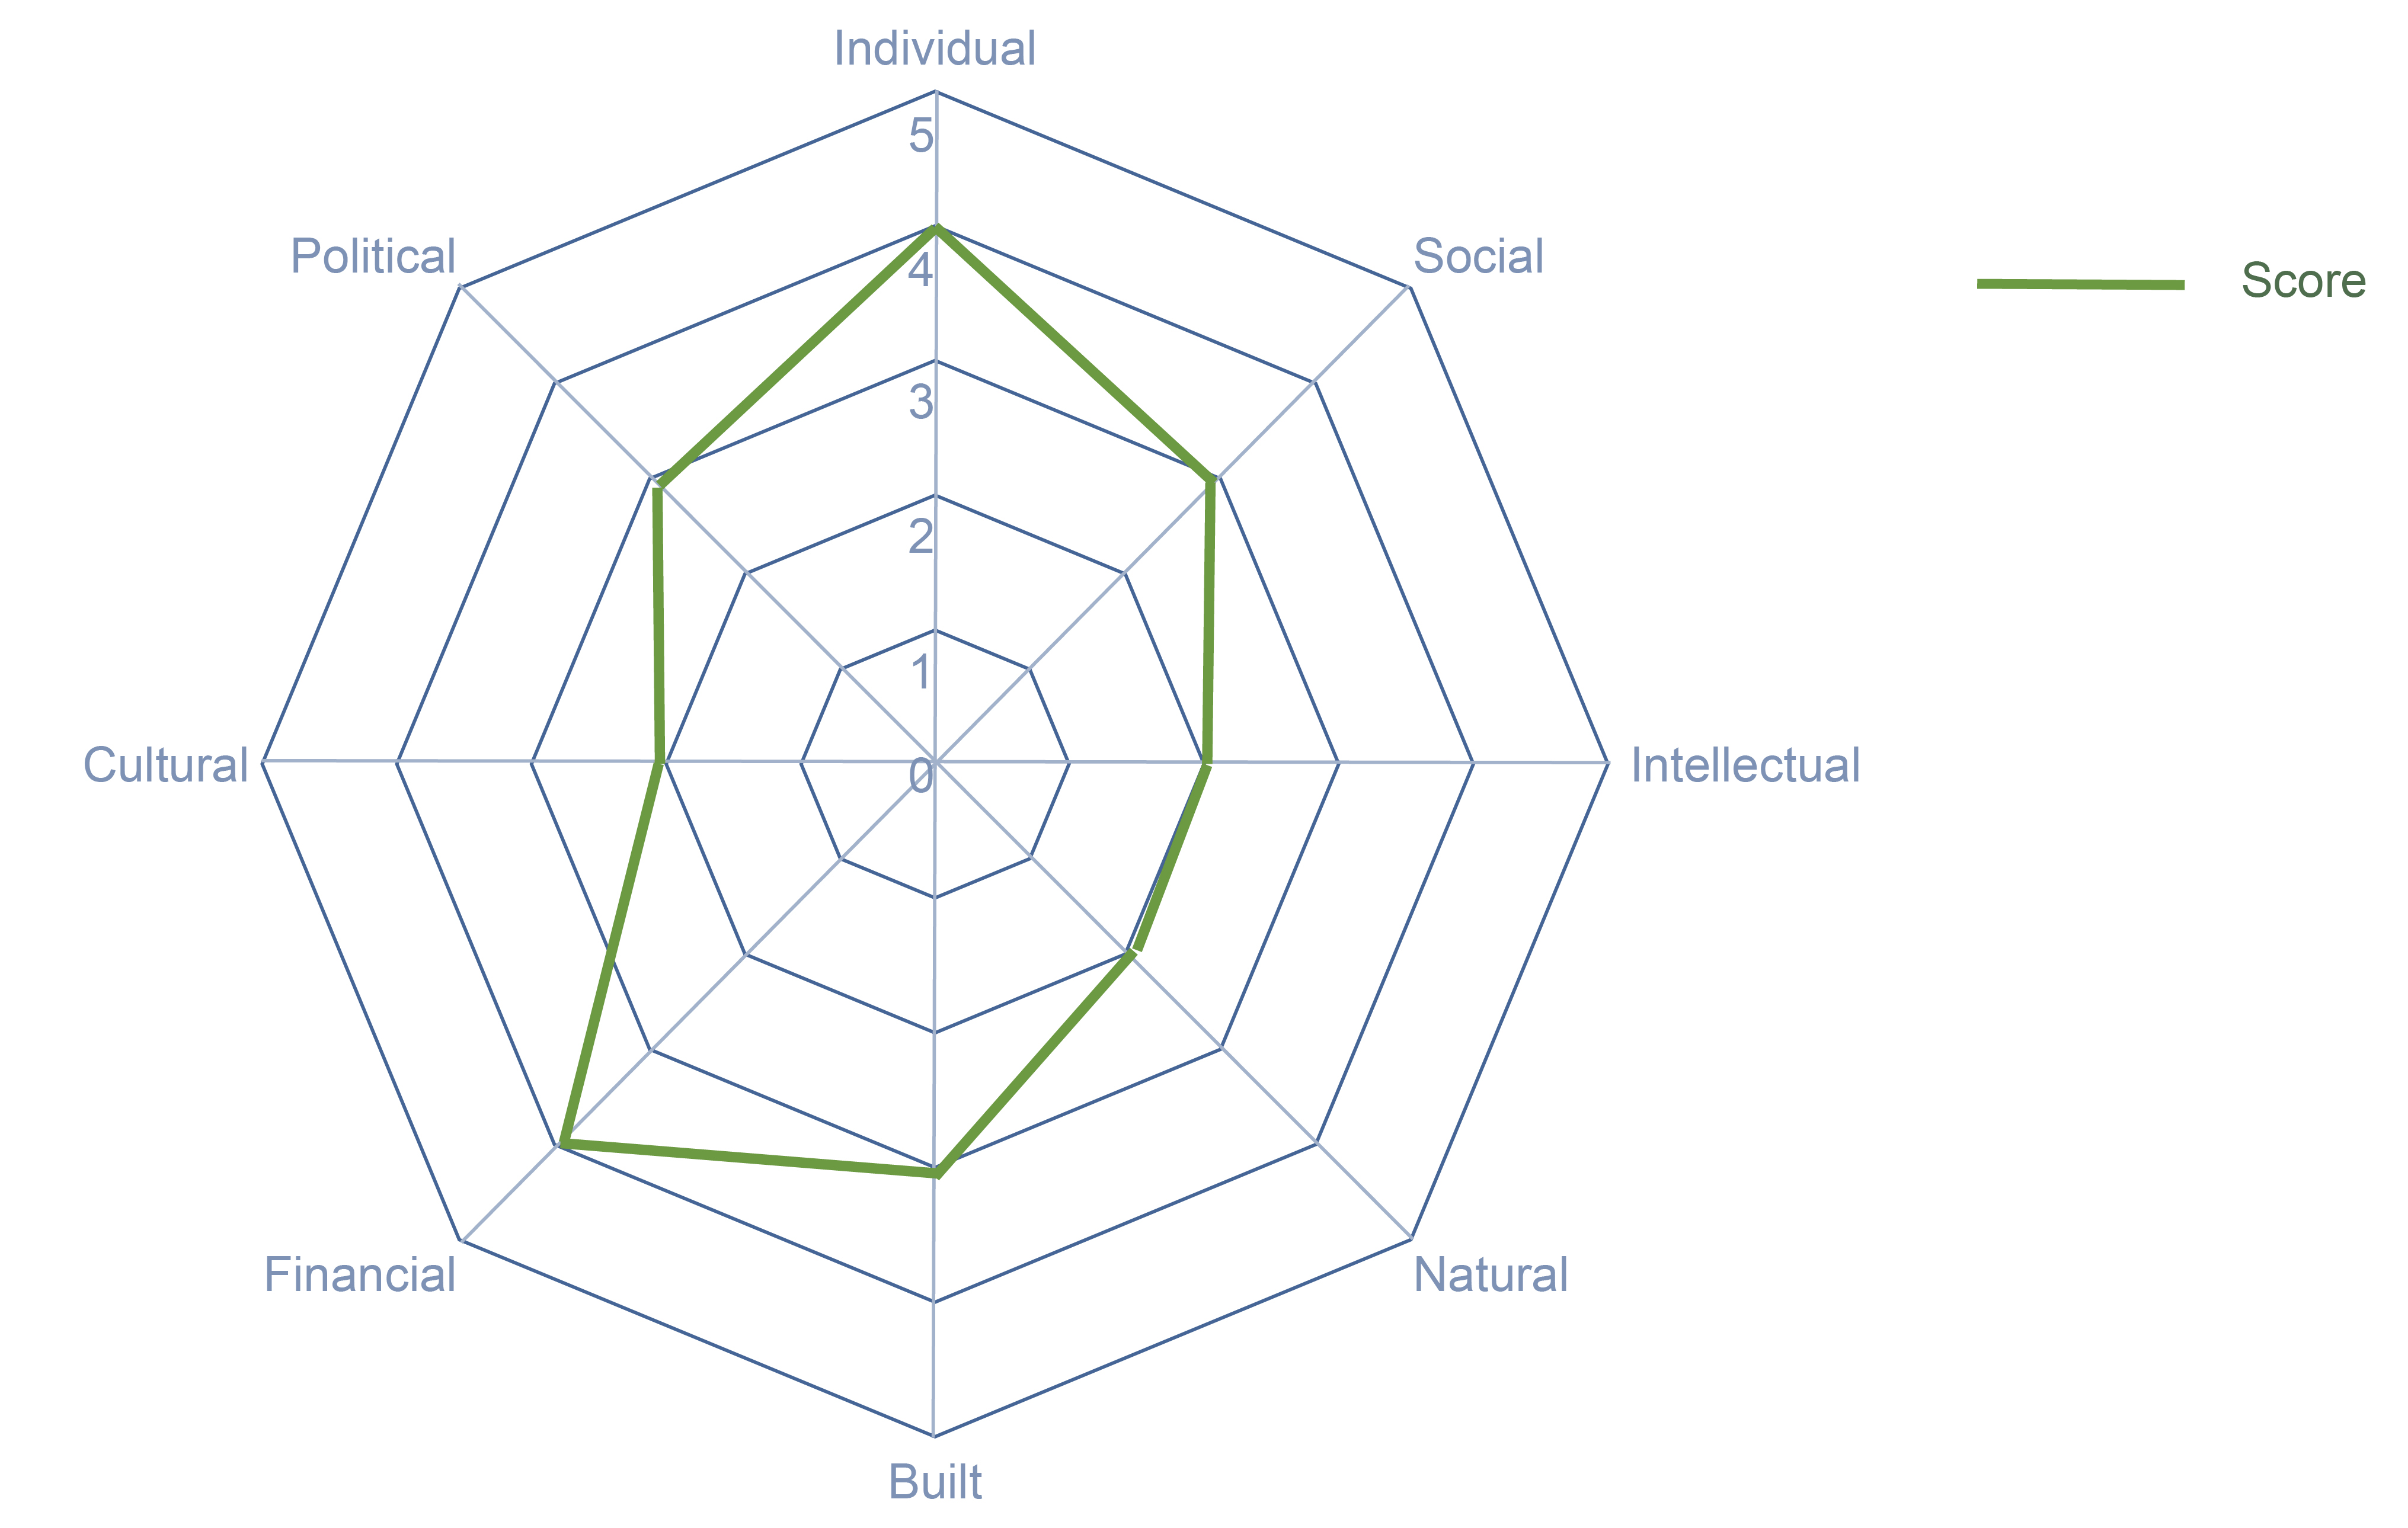

Spider Diagram Exercise: What is the Relative Strength of the Capitals in my Region?

Questions
- On the spider diagram below, map the strengths of each capital in your region? (0= weakest, 5= strongest).
- Explain your map. What did you come up with? Why?

