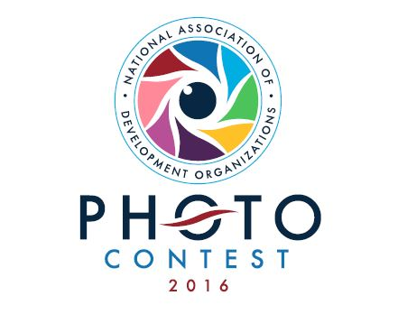
2016 NADO Photo Contest Entry Form
Thank you for participating in the 2016 NADO Photo Contest! Please submit this completed form, along with your photos, via e-mail to Brett Schwartz at bschwartz@nado.org by September 16. If your files are too large to e-mail, you may also submit via Dropbox to the same e-mail address.
/////////////////////////////////////////////////////
Please check:
[ ] I have read the rules and submission requirements for the NADO Photo Contest at NADO.org
[ ] My organization is a NADO member
[ ] I understand that the photos submitted will be shown at the Annual Training Conference in San Antonio and may also be used in NADO and NADO Research Foundation publications and on the NADO website and social media
Name:
Organization:
E-mail:
Date:
Please check the categories for which you are submitting photos (2 photos maximum per category):
[ ] Building Vibrant Places
[ ] Strengthening the Built and Natural Environments
[ ] Investing in Our Regional Economy
[ ] Sustaining Our Communities
Complete the following information for each photo submitted (cut and paste more sections if necessary):
The subject of the photo is:
The location of the photo is:
The staff member who took the photo is:

Please direct any questions to NADO Research Foundation Program Manager Brett Schwartz at bschwartz@nado.org

