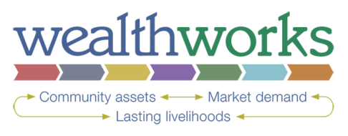
Capital | How do YOU MEASURE INCREASE IN capital?
 | Indicators | Measures
Individual: Skills, physical health and mental wellness in a region’s people
Intellectual: Knowledge, creativity and innovation in a region’s institutions and sectors

Social: Trust, relationships and networks
Natural: Water, land, air, minerals, plants and animals, ecosystem services and other natural resources in a place
Built: Constructed infrastructure, including buildings, sewer and water systems, communications systems, and roads
Political: Goodwill, influence and power that people and institutions in the region can exercise in decision-making.
Financial: Monetary resources available for investment in the region

Extra Credit:
- What indicators and measures could you use to assess inclusion?

- What indicators and measures could you use to assess local ownership?

